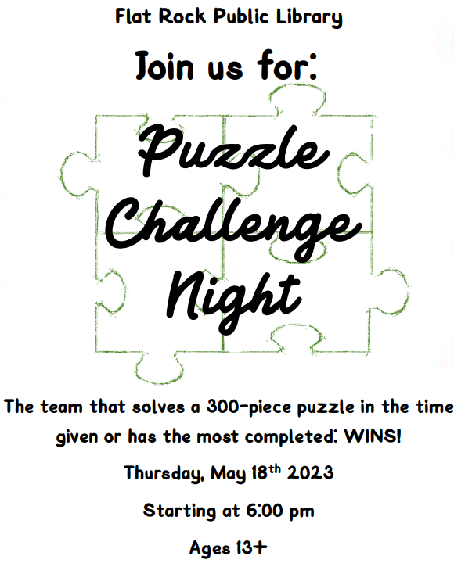

The team or individual that solves the 500-piece puzzle first or has the most completed in the given time wins!

**THURSDAY AUGUST 29 @ 6:00PM**

Starting at 6:00 pm

Ages 13+

Registration is required. You may register in person,

or by calling the library at (734) 782-2430

**Please register no later than Tuesday, MAY 14th**