***Ladies Movement and Mindfulness Practice  
with Denielle from Wild Earth Wisdom  
at the Flat Rock Public Library***

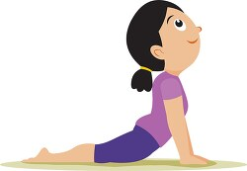

**When**: Mondays March 3rd, 10th, 17th, and 24th at 6 PM

**Who**: This particular program is for **ladies only, ages 12 thru adult**.

**What**: This a 4-week program. You do not have to attend all four   
 weeks to receive the benefits.

**Cost**: This is a **FREE** Class.

These classes are somatic. What is somatic? Somatic means relating to the body. Practices might include yoga, qi gong, self-massage, meditation, breathwork, ecstatic dance, and much, much more. We will do a variety of practices to get into the body, to calm our minds and come back to grounding. This practice will include breathwork, meditation, yoga and one other practice. You do not have to be a yogi master or even have tried yoga before as I will be offering modifications to suit every level.

To **sign up** for the class, please call, text, or email Denielle at 734-775-2085 or [**wildearthwisdomllc@gmail.com**](mailto:wildearthwisdomllc@gmail.com). You can also just show up at the library but signing up allows me to be sure I have enough materials. **Please bring** a yoga mat, yoga blocks, a blanket, a pillow, a journal and pen and water. If you do not have these items, I will have a limited amount for borrow.