FLAT ROCK PUBLIC LIBRARY PRESENTS  
 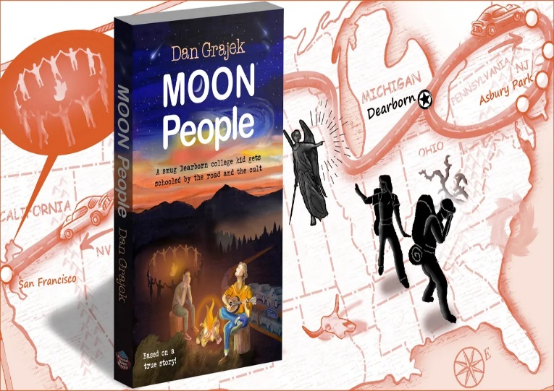

**DAN GRAJEK: MOON PEOPLE**

*Local resident & author Dan Grajek recalls his Dearborn college days and the road trip that  
 led him to the Moonie cult.*

**Thursday, January 25th @ 6:30 p.m.**   
in the activity room.   
Light refreshments will be served.

*Most remember the Kool-Aid-drinking Jim Jones cult, but few recall the Moonies, the original “doomsday cult.” Eight months after over 900 people perished in Jonestown, Ted Granger—then an idealistic U of M Dearborn student—joined the Moonies in San Francisco. Naturally, his parents back home feared the worst….   
This book has the unique perspective of Henry Ford’s hometown—Dearborn, Michigan—where the residents celebrate history, hi-tech (as it relates to cars), and religion.*

**ARRIVE EARLY, SEATING IS LIMITED**